SEV Patient Transfer Form
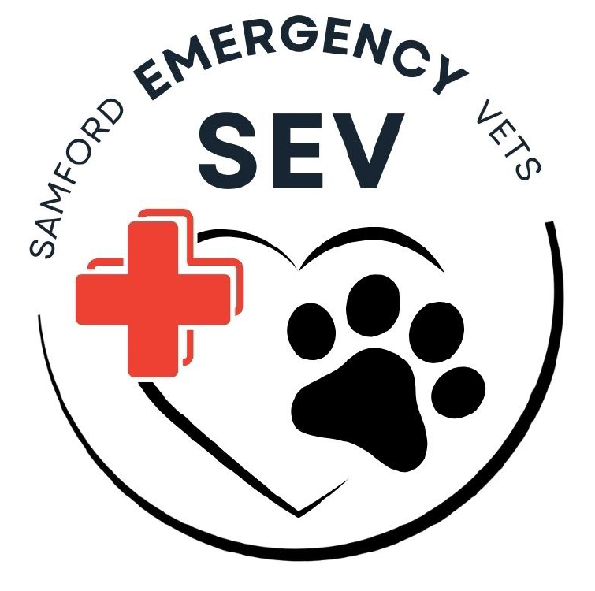
Please complete the following form and email to reception@samfordemergencyvets.com.au along with relevant history & diagnostics.

Once sent, please call 3289 9073 after 6pm for a vet-to-vet handover.

Referring Clinic: ____________________________ Referring Vet:_______________________________

Email:____________________________________ Contact Number:____________________________

Client Information
Name:__________________________________ Contact Number:_____________________________

Address:_______________________________________________________________________________

Patient Information
Name:________________________ Breed:_______________________ Age:_________
Gender:____________ Weight:______________ Temperament:_____________________________

Transfer Information
Presenting Complaint:____________________________________________________________________

Clinical Diagnosis:_______________________________________________________________________

Findings/diagnostics/procedures performed:_______________________________________________
_________________________________________________________________________________________

Expected Prognosis:______________________________________________________________________

Overnight treatment plan to be continued at Samford Emergency Vets
IVFT
Fluid type |  | Additives |  | Rate |  |  | Supplied?
Medications
Drug | Dose (mg/kg) |  | Route |  | Frequency | Time |  | Supplied?
Diagnostics
Type |  |  |  |  |  | Frequency |  | Time
Other

Plan for following day (please circle): discharge home / return to referring vet

***Please note: SEV will honour a discounted hospitalisation/examination fee for clients that are transferred from their referring vet with a COMPLETE CARE PLAN in place. This included a completed transfer form, a copy of all relevant patient history and diagnostics performed. If a care plan is no in place, our regular emergency fees will apply.

